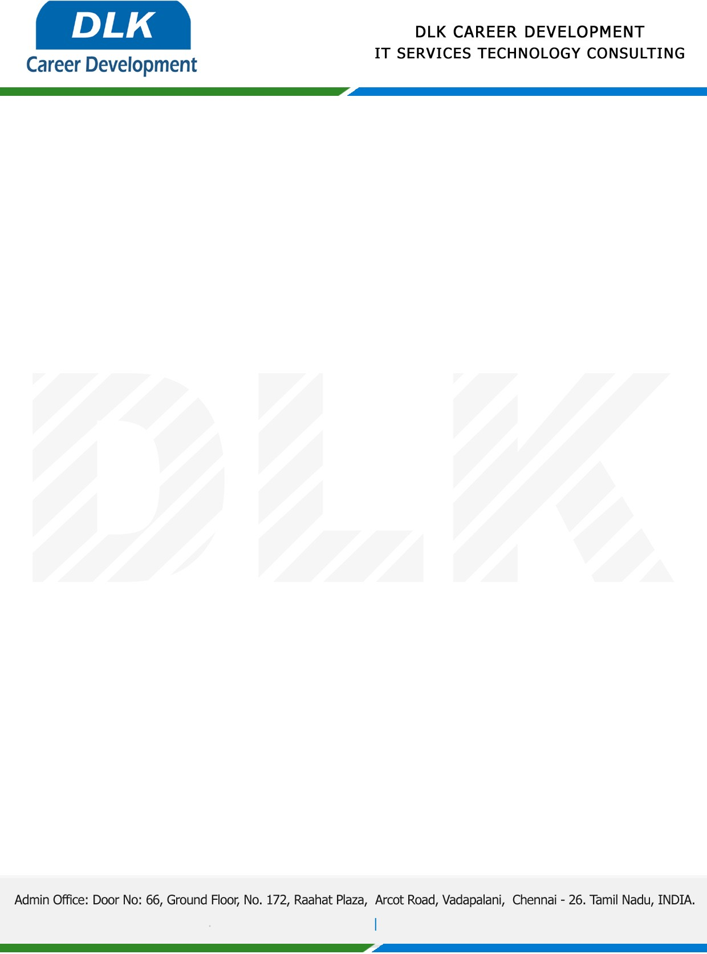

**Date: 19/April/ 2023**

**SUB: PROJECT COMPLETION CERTIFICATE**

This is to certify that **MR BHUVANESH V (REG NO:** **SP21CPP016) MSC – Computer Science,** final year student at **St.Peter's Institute of Higher Education and Research** has Successfully Completed his Project Work under the domain of “**PYTHON”** in our organization during the Period **(10th November 2022 to 25th March 2023)**

**Topic**: Rice Quality Analysis Using Deep Learning in python

We appreciate your interest in **DLK CAREER DEVELOPMENT**

**“Best Wishes for Your Future Endeavors “**

